RESOLUTION 05-29-2025

TOWN OF KIOWA

RESOLUTION SETTING UTILITY RATES FOR

DISCONNECTION & RECONNECTION FEES.

BE IT RESOLVED BY THE Board of Trustees for the Town of Kiowa this 29th day of MAY 2025

The addition & update of fees for disconnecting & reconnection of residential & commercial water service for the Town of Kiowa Public Works Authority is making these changes.

BE IT FURTHER RESOLVED That the fee cost be added for disconnection and the fee raised for reconnection for the Town of Kiowa Customers. All customers occupied residences and business within the Town of Kiowa limits. Unless otherwise provided for, it must be pay upon services being rendered.

BE IT FURTHER RESOLED that this Resolution shall be for the nonpayment of utility bills incurred by residents and customers of the Town of Kiowa PWA. Rates can be reviewed annually at any regular monthly meeting and raised as needed by a vote of the Town of Kiowa Board of Trustees.

Furthermore, declaring an emergency exists and that these rates will be in full force and effective as of June 1 st, 2025.

Adopted and approved this 29th day of May 2025.

# FILED

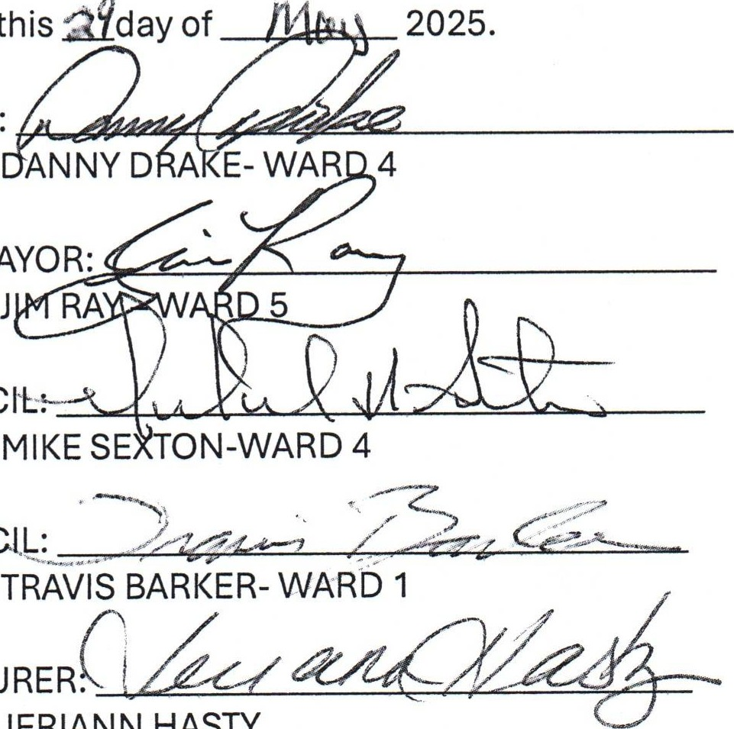

JERIANN

HASTY

Signed

this

a9day

MAYOR:

VICE

MAYOR:

COUNCIL.

COUNCIL:

TREASURER.



DEPUTY

JUN 2 3 2025

ATTEST:

TOWN CLERK:

KRISTINA BURGETT

PUBLIC WORKS AUTHORITY MINUTES

FOR REGULAR MONTHLY MEETING

MAY 29, 2025 @ 6:30 P.M.

AT KIOWA CITY HALL

831 S. VAN BUREN ST. KIOWA, OK 74553

All items on this agenda, including but not limited to any agenda item concerning the adoption of any ordinance, resolution, contract, agreement, or any other item of business, are subject to amendment, including additions, corrections and/or deletions. This rule will apply to every individual agenda item without exception, and without providing this same amendment language with respect to each individual agenda item. Such amendments should be rationally related to the topic of the agenda item, or the governing body will be advised to continue the item.

The governing body may adopt, approve, ratify, deny, defer, recommend, amend, strike, or continue any agenda item. When more information is needed to act on an item, the governing body may refer the matter to its City/Trust Manager, staff, Attorney or to the recommending board, commission or committee.

CALL MEETING TO ORDER: The meeting was called to order at 6:30 p.m.

PLEDGE OF ALLEGIANCE & INVOCATION: Completed.

ROLL CALL: Mike Sexton-present, J. Ray-present, D. Drake-present, T.S. Barker-present, J. Hasty-present and K. Burgett-present.

APPROVAL OF MINUTES: On a motion duly made by D. Drake and seconded by J. Ray, M. Sexton-yes, J. Ray-yes, D. Drake-yes, T.S. Barker-yes, J. Hasty-yes and K. Burgett-yes, the motion carried to approve the minutes as presented.

APPROVAL OF FINANCIAL REPORT: Tracy Reed of RSMeacham CPA & Advisors reported that we are 83% through our budget year. She further reported that Total Cash is $2.9 million and that we have experienced a good steady cash flow throughout the year. On a motion duly made by D. Drake and seconded by M. Sexton, M. Sexton-yes, J. Ray-yes, D. Drake-yes, T.S. Barker-yes, J. Hasty-yes and

K. Burgett-yes, the motion carried to approve the Financial Report.

APPROVAL OF PURCHASES: There were no questions regarding the Purchases Report. On a motion duly made by D. Drake and seconded by M. Sexton, M. Sexton-yes, J. Ray-yes, D. Drake-yes, T.S. Barker-yes, J. Hasty-yes and K. Burgett-yes, the motion carried to approve the Purchases Report.

WATER PLANT REPORT: D, Dibble reported that everything is back up and running. He further reported that the flushing of the lines will begin May 30, 2025. D. Drake asked that D. Dibble check the water at the end of the line as well and report back to him with his findings. No vote was required in this matter.

1. Discussion, consideration and possible action: Public hearing for FY25-FY26 budget. Tracy Reed ofRSMeacham CPA & Advisors presented the finished FY25-FY-26 budget. T. Reed also noted that there are no rate changes for water and sewer included in this budget due to the strong revenues throughout the year. This matter will be reviewed in 6 months time. Trash will increase due to the 4.9% pass-thru that our Provider has as a part of our contract with them. T. Reed noted that the Town of Kiowa has a very robust budget for a town our size. Mayor D. Drake asked all in attendance as a part of the public hearing if they would like to ask questions or speak regarding the FY25-FY-26 budget. There were not questions asked. Therefore, D. Drake declared this Public Hearing closed at 6:45 p.m. No vote was required in this matter as it is to be adopted in Agenda Item #2 by Resolution.
2. Discussion, consideration and possible action: Adoption of the FY2025-FY2026 budget resolution. On a motion duly made by D. Drake and seconded by M. Sexton, M. Sexton-yes, J. Ray-yes, D. Drake-yes, T.S. Barker-yes, J. Hasty-yes and K. Burgett-yes, the motion carried to approve the FY2025-FY2026 budget by resolution.
3. Discussion, consideration and possible action: Rural Water rate increase to S 4.59 and Town of

Kiowa rates for water to be increased. On a motion duly made by M. Sexton and seconded by J. Ray, M. Sexton-yes, J. Ray-yes, D. Drake-yes, T.S. Barker-yes, J. Hasty-yes and K. Burgett-yes, the motion carried to table this matter at the present time.

1. Discussion, consideration and possible action: Water adjustment for Bertha Lambert. On a motion duly made by D. Drake and seconded by M. Sexton, M. Sexton-yes, J. Ray-yes, D. Drake-yes, T.S. Barker-yes, J. Hasty-yes and K. Burgett-yes, the motion carried to approve the sewer only adjustment in the amount of $15.06 for Bertha Lambert.
2. Discussion, consideration and possible action: Change the amount of the reconnect fee and add a disconnect fee. On a motion duly made by D. Drake and seconded by J. Ray, M. Sexton-yes, J. Ray-yes, D. Drake-yes, T.S. Barker-yes, J. Hasty-yes and K. Burgett-yes, the motion carried to change the reconnect fee to $100.00 and add a disconnect fee of $100.00; with this change to be enacted after the customer has been notified. (Written notification will be sent to the customer prior to these changes going into effect.)

NEW BUSINESS: D. Drake asked water plant personnel to get their required licenses. J. Hasty reported that after today, the two employees will have either their C or D licenses for the water plant. D. Drake further noted that he wants to meet next week with Town personnel and DEQ in an effort to provide the cleanest water possible for the Community.

L. Shows reported that back in January 2022, there was a 15% raise in utilities. No increase in utilities has been done since that date. D. Drake asked that we hold off for now in increasing our rates. He further noted that he and D. Dibble will get with L. Shows in a few days to further discuss this matter.

L. Shows noted that she has a survey from ORWA regarding an update on rates. T. Reed reported that grant money may be available. She also noted that ORWA likes to see a lower burden on residential homes with a higher burden on industrial and commercial properties.

D. Drake asked D. Dibble to fully train Josh Furr at the water plant; and that Brandon Thomas be removed from the water plant. D. Drake further asked that other Town personnel be cross trained also and to include J. Wilson and L. Shows in that training. D. Drake stated that this training is needed in case D. Dibble is not available. D. Drake asked D. Dibble not to be offended by this action and that he wants this cross training to be completed.

PUBLIC DISCUSSION: None.

ADJOURNMENT: On a motion duly made by D. Drake and seconded by M. Sexton, M. Sexton-yes, J. Ray-yes, D. Drake-yes, T.S. Barker-yes, J. Hasty-yes and K. Burgett-yes, the motion carried to approve the adjournment of the meeting at 7: 12 p.m.

IF ASSISTANCE IS NEEDED PLEASE NOTIFY THE CITY HALL AT 918-432-5621, 24 HOURS IN ADVANCE.KIOWA, OKLAHOMA.

